AMHERST ORTHODONTICS APPOINTMENT SUMMARY

Date:__________________ Patient:_________________________________________________________

Your child was seen by : Dr. Diane Assistant:_____________________________

A regular adjustment
⁫Changed/Adjusted wire(s) in the: ⁫upper teeth ⁫ lower teeth
⁫Changed color ties on braces
⁫Continued with closing spaces
⁫Evaluated the overall bite/ elastic wear and made adjustments as needed

Reviewed elastic wear:
⁫Started elastics: When to wear: ___________________ Size:______________
⁫Changed elastic direction: When to wear:____________________Size:______________
⁫Changed elastic strength: When to wear:____________________Size:______________
⁫Continued current elastics: When to wear:____________________Size:______________
⁫Discontinued / Not Applicable
⁫Elastics are not being worn enough, please continue to act as our partner to encourage excellent wear

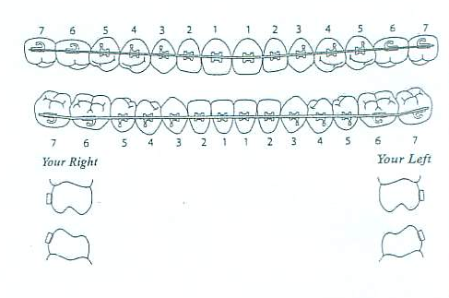
We added or repositioned: ⁫Braces ⁫Bands

There was a broken band or brace:
⁫We repaired what was broken
⁫Repair was not necessary today
⁫We will repair at a future visit

We performed:
⁫Molds of teeth ⁫X-rays(s)
⁫Photos ⁫Placed spacers: _________

An appliance was:
⁫Inserted ⁫Checked and is doing its job.
⁫Recemented ⁫Removed/Discontinued

Braces were removed, congratulations! Please see attached for more information.

Brushing and Flossing (letter grade below)
⁫ A ⁫ B ⁫ C ⁫ D ⁫ F
Instructions:_______________________________________________________________________________

Appointment Notes:_____________________________________________________________________________________

_______________________________________________________________________________________________________

_______________________________________________________________________________________________________

Next Appointment Information:___________________________________________________________________________

_______________________________________________________________________________________________________

A Spike Mobile Reservation was made for your child (see attached).
The Spike Mobile is not appropriate for the next visit. Please call to schedule the next appointment as soon as possible.
Not applicable
Please feel free to call us with any questions or concerns: 603-672-0844

