

**2017 FEBRUARY NEWSLETTER!**

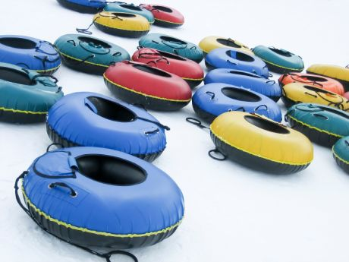

**Patient Appreciation**

How do we love our patients?

Please join us on Saturday March 11th from 9-11 for a fun day of Snow Tubing at Mcintyre Mountain! Tickets are only $5 per person!! If you want to join us please sign up with the front desk!

FUN AROUND THE OFFICE!!

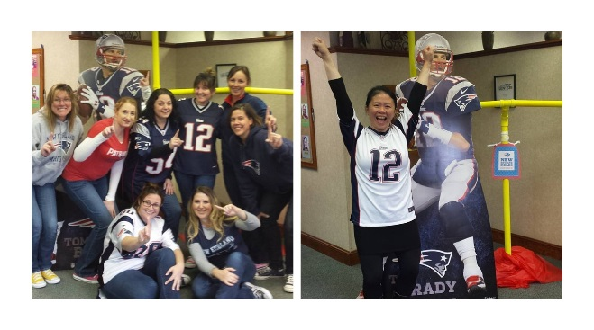

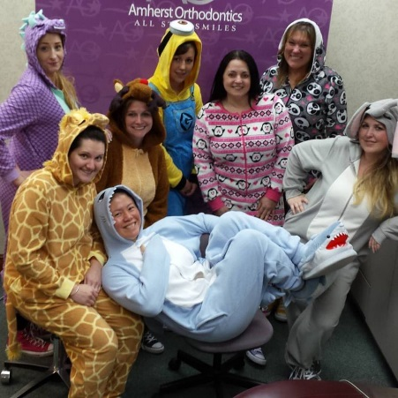

Thanks to all those who helped cheer the Patriots to another Superbowl victory!!

**PAJAMA WEEK!!!**



**Happy Valentine’s Day!!!**

**(Chocolate is the perfect braces treat!)**

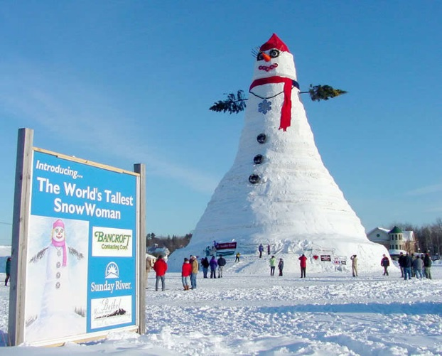

### The largest recorded snowman ever built was in Bethel, Maine, in February 1999. It was a whopping 113 feet tall.



**2017 FEBRUARY NEWSLETTER!**

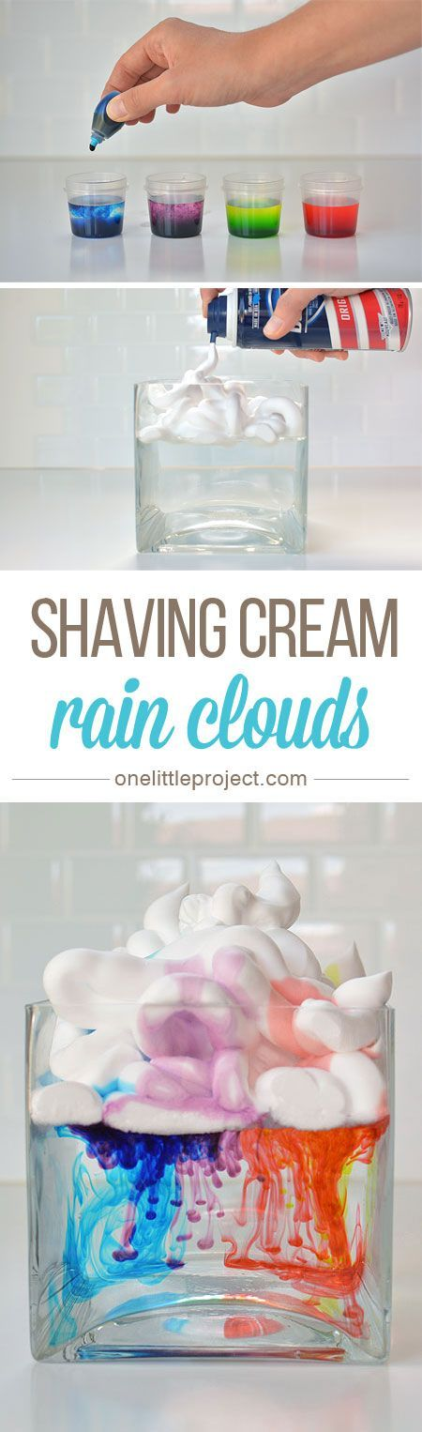

***On April 8th we Proudly host our annual……***

**Boy Scout Dentistry Merit Badge**

Shaving Cream Rain Clouds

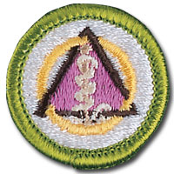

***What we’ll cover……***

* Dental Anatomy
* First Aid for Dental Traumas
* Biology of Cavities and Dental Disease
* “Hands-on”

Lab Experience

WHAT YOU’LL NEED

* A couple of clear glasses, vases, or bowls (it’s fun to switch up the shapes and sizes!)
* Food coloring
* Shaving cream
* Water
* An eye dropper, syringe or 1/4 teaspoon measuring spoon

**Then and Now Contest**

Congratulations to Nicholas!! He won a game basket including “Speak Out” for matching all 10!



* Fill the vase or bowl ¾ of the way with water
* Create a Cloud with the shaving cream on top of the water.
* Let the foam settle a little bit
* Now drop food coloring into the shaving cream cloud using the syringe or the teaspoon and watch what happens!

**What do Snowmen eat for breakfast?**



Frosted Flakes ☺